**LongDriver Installation Guide**

**Self-Balancing Two-Wheel Vehicle**

**Contents**

LongDriver Installation Guide 1

Self-Balancing Two-Wheel Vehicle 1

1. Component List 2

Frame Components 2

Electronics 2

2. Required Tools 6

3. Assembly Steps 6

Connection diagram 6

4. Electrical Connections 7

Step 1: Power System 7

Step 2: Motor Connections 7

Step 3: Sensor Connections 7

Step 4: Remote Control 8

5. Software Setup 8

Step 1: Arduino IDE Setup 8

Step 2: Code Upload 8

Step 3: Initial Configuration 8

6. Testing and Calibration 9

Step 1: System Check 9

Step 2: Balance Testing 9

Step 3: Remote Control Test 9

Important Notes 9

# 1. Component List

**Frame Components**

* 2 wheels (16cm diameter)
* Plastic/aluminum rectangular frame (20x30cm)
* 8mm steel axle
* 608ZZ bearings set
* Nuts and bolts set
* Mounting brackets

**Electronics**

* Arduino Mega/Uno board

Figure 1. Arduino Mega/Uno board

* MPU6050 gyroscope/accelerometer

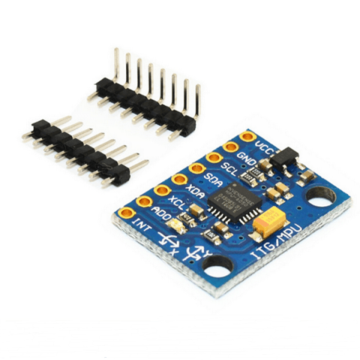

Figure 2. MPU6050 gyroscope/accelerometer

* 2 DC motors 12V (150-300 RPM)

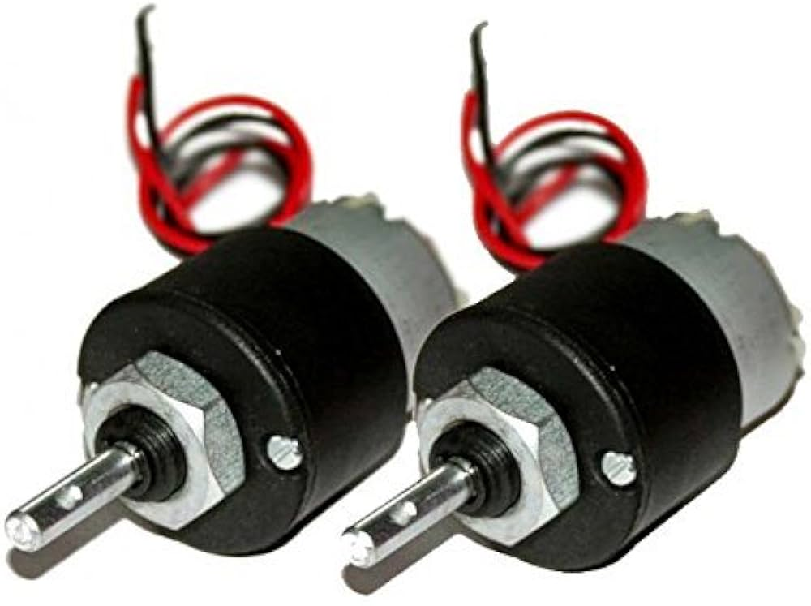

Figure 3. 2 DC motors 12V (150-300 RPM)

* L298N motor driver

Figure 4 L298N

* RF24L01 remote module

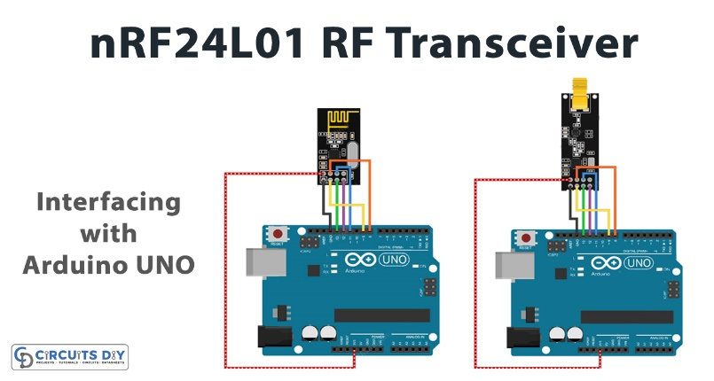

Figure 5. RF24L01 remote module

* Battery connectors

Figure 6 Battery

* Motor wheel

Figure 7. wheel

* LongDriver frame

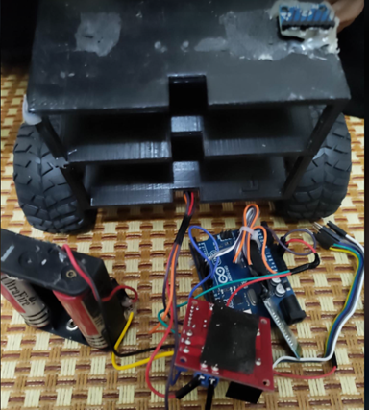

Figure 8 LongDriver frame

# 2. Required Tools

* Phillips and flathead screwdrivers
* Pliers
* Wire cutters
* Soldering iron and solder
* Electrical tape
* Wrench set
* Caliper
* Multimeter
* Heat shrink tubing
* Cable ties

# 3. Assembly Steps

## Connection diagram

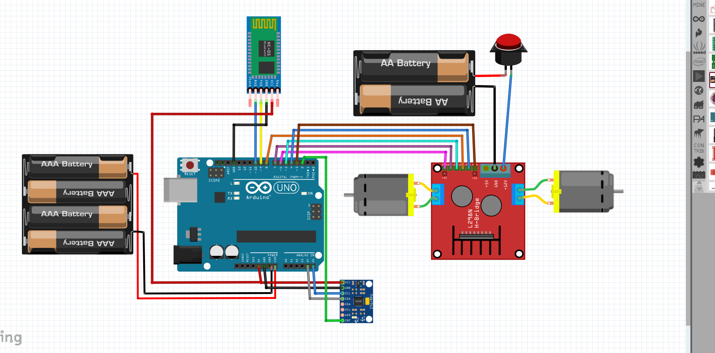

Figure 9. Connection diagram

**Step 1: Frame Assembly**

1. **Base Frame Preparation**
   * Clean all frame components
   * Lay out the base plate (20x30cm)
   * Mark mounting points for:
     + Motors
     + Battery compartment
     + Electronics board
     + Sensor mounting
2. **Wheel Assembly**
   * Install bearings into wheel hubs
   * Insert 8mm axle through bearings
   * Secure wheels with lock nuts
   * Check wheel rotation smoothness
3. **Motor Mounting**
   * Attach motor brackets to frame
   * Align motors with wheel axles
   * Secure motors using M3 bolts
   * Verify motor shaft alignment

**Step 4: Electronics Mounting**

**1 Control Board Installation**

Arduino Mounting:

- Position in center of frame

- Use mounting spacers

- Secure with M3 screws

**2 Sensor Installation**

MPU6050 Mounting:

- Mount at frame center

- Ensure horizontal level

- Use double-sided tape/screws

**3 Motor Driver Installation**

L298N Mounting:

- Mount near motors

- Allow ventilation space

- Secure with screws

# 4. Electrical Connections

### Step 1: Power System

Battery → Switch → L298N

L298N → Arduino (5V)

### Step 2: Motor Connections

L298N to Motors:

OUT1, OUT2 → Left Motor

OUT3, OUT4 → Right Motor

### Step 3: Sensor Connections

MPU6050 to Arduino:

VCC → 5V

GND → GND

SDA → A4

SCL → A5

### Step 4: Remote Control

RF24L01 to Arduino:

VCC → 3.3V

GND → GND

CE → Pin 7

CSN → Pin 8

SCK → Pin 13

MOSI → Pin 11

MISO → Pin 12

MISO → Pin 12

# 5. Software Setup

**Step 1: Arduino IDE Setup**

1. Download and install Arduino IDE
2. Install required libraries:

- Wire.h

- MPU6050.h

- RF24.h

- PID_v1.h

**Step 2: Code Upload**

1. Download project code
2. Configure board settings:

Board: Arduino Mega

Processor: ATmega2560

Port: COM[X] (select correct port)

1. Upload code:
   * Open Arduino IDE
   * Load project file
   * Verify code
   * Upload to board

**Step 3: Initial Configuration**

1. MPU6050 Calibration:

void calibrateSensor() {

// Place vehicle upright

// Run calibration routine

// Save offset values

}

1. PID Tuning:

double Kp = 15;

double Ki = 0.5;

double Kd = 0.8;

# 6. Testing and Calibration

**Step 1: System Check**

1. Power up system
2. Check LED indicators
3. Verify sensor readings

**Step 2: Balance Testing**

1. Hold vehicle upright
2. Power on
3. Slowly release
4. Observe self-balancing

**Step 3: Remote Control Test**

1. Power on remote
2. Test basic movements:
   * Forward/Backward
   * Left/Right turns
   * Emergency stop

# Important Notes

* Double-check all connections before power-up
* Label all wires for maintenance
* Keep detailed assembly photos
* Start with conservative PID values
* Regular maintenance schedule:
  + Check battery voltage
  + Tighten all screws
  + Clean wheel bearings
  + Update software as needed